ILS NEWS

INTERNATIONAL LIFE SAVING FEDERATION

Gemeenteplein 26 – 3010 Leuven – Belgium
Tel: (32.16) 35.35.00 – Fax: (32.16) 35.01.02
E-mail: ils.hq@pandora.be
Web: http://www.ils.org

ILS NEWS (2000/3)

Introduction

After the summer meetings we herewith forward you the third Newsletter of ILS. All info you would like to see published in the ILS Newsletters must be submitted to the ILS Headquarters. We welcome all news.

Hungary on the move

The Hungarian Lifesaving Federation (HLSF) has been very active this summer with the organisation of a lifesaving clinic with over 50 participants. Besides several Hungarian specialists, such as Miklos Medec and Dr. Tibor Kozsla, Prof. Morrie Chiang and the ILS Secretary General were appointed co-teachers in the course that took place at the Hungarian University of Physical Education under the responsibility of Dr. Tibor Kozsla, Head of the University International Department. At the occasion of the course, the Belgian Life Saving Federation donated two resuscitation manikins to the HLSF.

Elections in Hungary

At its General Assembly last week, Mr. Miklos Medec was re-elected President of the Hungarian Life Saving Federation while Dr. Tibor Kozsla was elected Chairman of the Board. New Board members include highly positioned individuals in the Hungarian World of Lifesaving and Swimming. ILS Congratulates the new elected Board.

Malawi

The Malawi Life Saving Society has a new address:
Malawi Life Saving Society
P.O. Box 149
Namadzi – Malawi

The new Board is composed as follows:
President: Mrs. C.T. MSISKA
Secretary General and Treasurer: Justice T. MAHILASI
Board Members: Mr. KAIYA, B. BANDA, KANSINA, POTANI, M. MAHILASI, M. NAKULA and Mrs. C. MAHILASI and NEVETI.

ILS congratulates the new elected Board.

South Africa

President: Alan Pembroke
Vive president: Dylan Tommy
Competition Director: Jelle Meintsma
Director Lifesaving: Anna Venter
Director Development: Ernie (Gus) Malgas
Director Education and Training: Pat Wilcox
Director Patrols: Lionel Bruinders
Director Junior Activities: Dylan Tommy
Director Finance: Rob Nixon
CEO: Rashard Davids
Administration Manager: Brian Jones
Medical Advisor: Dr Mike Marshall
Legal Advisor: John Pammenter SC and
Norman MacRitchie

ILS wishes to congratulate and to welcome the SALSA Board.

ILS Headquarters

Some changes took place at the ILS Headquarters. Mss Heidi Heremans decided last month to re-orient her life and to move to Toulouse in the South of France where she will live closer to her boyfriend. ILS wishes Heidi a happy future and thanks her for her outstanding work and dedication the last three years.

Inge Moerman took over the job of Heidi from 1 November onward. Inge is a University Graduate in Classical languages and speaks (besides Latin and Greec) over four languages. Inge was the best applicant out of over 30 and ILS welcomes Inge in her new job.

Last August, Ruth Masuy has enforced our Headquarters. Ruth is a Communication graduate and is working on the enhancement of the Communication Strategies of ILS. With the help of Ruth, ILS will strive to issue a Newsletter every month. We count on your help and collaboration to inform us on items of general interest and thank you in advance for your input.

Macau became Full Member of ILS.

The Board of Directors accepted at its last meeting that Macau could join ILS as a Full Member. We have the pleasure to welcome the Associao de Salvamento de Vidas de Macau that became Full Member of ILS on 27 July 2000.

H.E. Seyed Mirsalim visited the ILS Headquarters

ILS Patron Seyed Mirsalim from Iran visited the ILS Headquarters on 25 and 26 September 2000. Discussions took place on the evolution of ILS and the Development of Lifesaving in the Middle East Region. Proposals will be submitted to the ILS Board in December.

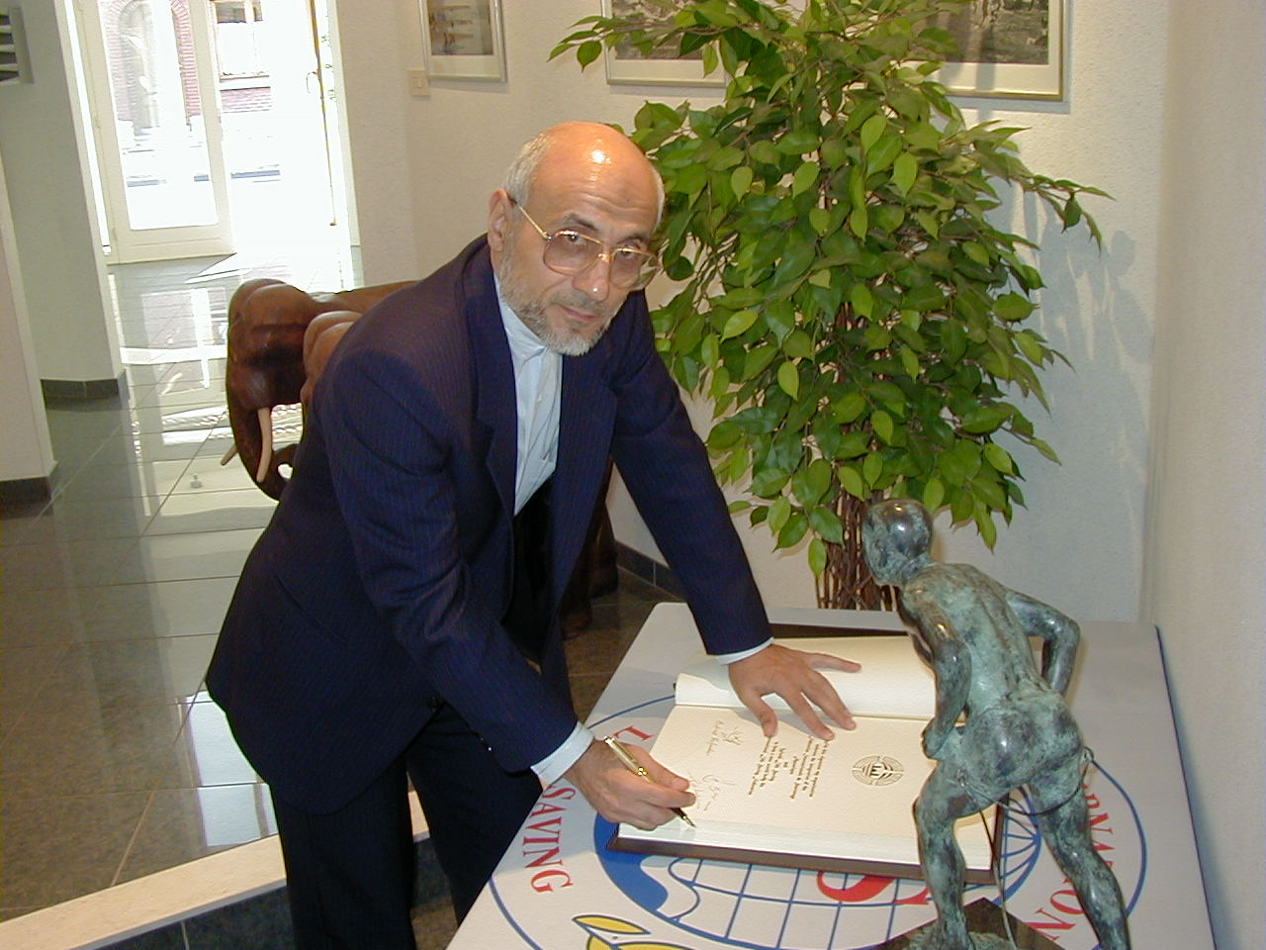

Rescue 2002 in Daytona Beach (USA)

The on-site inspection of Daytona Beach took place from 15 to 19 June 2000. Upon recommendation of the inspectors, the ILS Board of Directors formally adopted Daytona Beach as the venue for Rescue 2002. The tentative calendar is added to this Newsletter.

The Adam Mark Hotel in Daytona Beach

The Adam Mark Hotel was chosen to be main ILS Hotel of Rescue 2000. The Hotel has 437 top quality Ocean view rooms. Adjacent to the main building, a new wing for another 350 rooms has just started being constructed and will be finished well before Rescue 2002 takes place. The hotel is located at the Beach right in front of the Surf/Ocean Championships. If you want to visit the Hotel already now, go to:

http://www.visitdaytona.com/adamsmark

Call for organisers for Rescue 2004

All Full Member countries, willing to bid for the organisation of rescue 2004, are requested to inform the ILS Headquarters at their earliest convenience. Currently, the ILS Headquarters have registered three candidatures, namely Italy (Viareggio), Spain (Santander) and Belgium (Oostende).

Closer co-operation between International Olympic Committee and World Games

Twenty years after the foundation of the International World Games Association (IWGA), 1980 in Seoul (KOR), the International Olympic Committee (IOC) and the IWGA signed on 27th October 2000 in Monte-Carlo a memorandum of understanding between the two organisations for further co-operation.

The agreement was signed by IOC President Juan Antonio Samaranch and IWGA President Ron Froehlich. The ceremony was attended by:
- Dr Un Yong Kim, the IWGA Founder President and current GAISF President and IOC Executive Board Member
- Dr Jacques Rogge, IOC Observer to the IWGA Executive Committee and also IOC Executive Board Member
- Gilbert Felli, the IOC Sports Director.
- The IWGA Executive Committee: Bob De Die, Co Koren, Lukas Hinder, Dr. Harald Vervaecke and Roland Hilfiker.

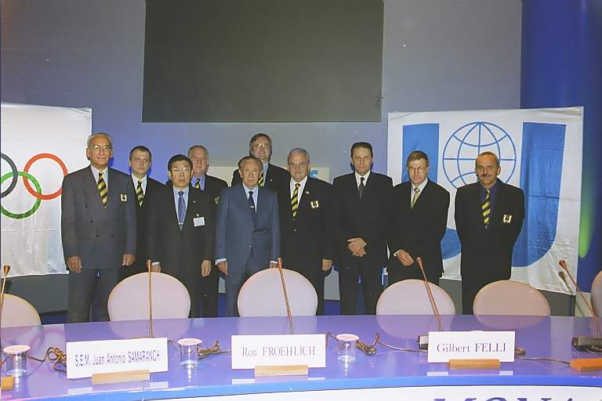

Organising Committees of World Games events will be granted IOC patronage and will be provided with technical assistance through the transfer of the IOC knowledge programme. The IOC will also encourage the National Olympic Committees (NOCs) to support and assist their national multi-sport delegations taking part in the World Games. The IWGA is willing to review and further develop the sports programme of the World Games with the help and the input of the IOC.

Furthermore, the IWGA shall continue to develop a close working relationship with the World Anti-Doping Agency (WADA) while the IOC agreed to grant funding to the Organising Committee of a World Games event for anti doping control.

The World Games is a four annual multi-sport event, organised in the year following the Olympic Summer Games, including these sports or disciplines of sports not yet included in the programme of the Olympic Games.

The first World Games took place in 1981 in Santa Clara, California (USA), followed by 1985 London (GBR), 1989 Karlsruhe (GER), 1993 The Hague (NED) and 1997 Lahti (FIN). The first World Games in the new millennium will also be the first World Games be ever held on the Asian continent, in Akita (JPN), 16-26 August 2001.

The programme for a World Games event is based on existing facilities within the host city and from 2005 on, there is a limited number of participating athletes and officials of no more than 3.000 in total, which either to participate in the Opening or either in the Closing Ceremony of the World Games.

Despite of the restriction mentioned above towards the inclusion in the competition programme, at the moment 31 International Sports Federations are affiliated with the IWGA. Among them five Olympic Federations for their disciplines not included in the Olympic programme, i.e. Archery, Canoe, Gymnastics, Handball and Hockey. Furthermore almost all Olympic Recognised Sports Federations are involved, i.e. Air Sports, Billiards, BodyBuilding, Boules Sports, Bowling, DanceSport, Karate, Korfball, Lifesaving, Netball, Orienteering, Pelota Vasca, Racquetball, Roller Sports, Rugby, Squash, Surfing, Tug of War, Underwater Sports and Water Ski.

Attached is a copy of the full text of the Memorandum of Understanding between the IOC and the IWGA

Duisburg is the host of the 2005 World Games

On 25 October, an agreement had been signed between the IWGA and the City of Duisburg, Germany, for hosting the World Games 2005.

World Games in 2009

At this date there are already six cities showing interest in bidding for hosting the World Games of 2009. Among them one in Europe (Budapest), two in Asia (Singapore and Taipei) and three in North America (Boston, Cincinaty and Dallas).

Data, data, data, …

During the holiday period, the staff at the ILS Headquarters was very active in grouping and computerising all data from the lifesaving World and European Championships as well as from the World Games, and that since 1956. The data can be found back on and can be downloaded from the ILS website.

Newsletter compiled by
Dr. Harald Vervaecke - Secretary General and
Ruth Masuy - Executive Assistant

