INTERNATIONAL LIFE SAVING FEDERATION

Gemeenteplein 26 - 3010 Leuven - Belgium
Tel: (32.16) 35.35.00 - Fax: (32.16) 35.01.02
E-mail: ils.hq@pandora.be
Web: http://www.ilsf.org

ILS NEWS
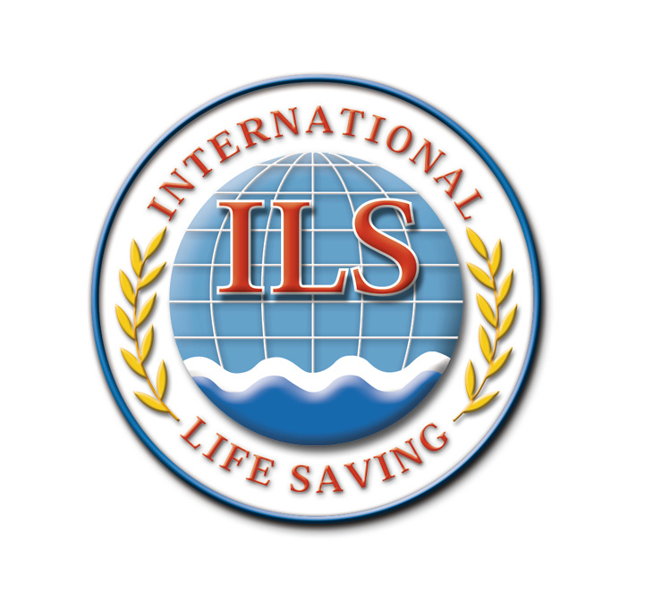
2005/04

Introduction

The ILS Headquarters wishes the ILS members all the best in the new year. We hope many lives will be saved and there will be a lot of friendship through lifesaving.

We look forward to the upcoming Board and Commission Meetings as well as the World Championship in February. For more information go to www.rescue2006.com

Handbook on Drowning published

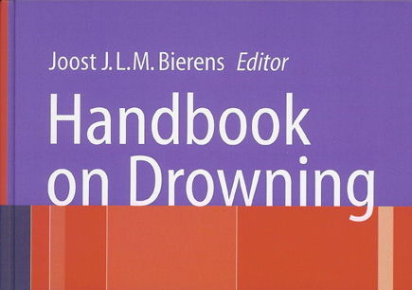

World-wide at least half a million people die from drowning each year. To address this global issue, experts from around the world, ranging from rescuers to clinicians and researchers, share their knowledge and expertise to focus on the major areas of need and strategies for success.

The Handbook on Drowning is the "must have" for anyone who desires a satellite view of existing knowledge about prevention, rescue, and treatment of drowning. The book is not only a rich source of focused information, but also a stimulant for initiatives on how best to reduce the annual number of drownings, in individual cases and during disasters, and how to improve the outcome of drowning victims.

The International Life Saving Federation participated in the organizing of this event and numerous ILS affiliated experts were participants. The book was edited by Dr. Joost Bierens, member of the ILS Medical Committee.
The Handbook is written for all persons involved in the pre-hospital, emergency and intensive care treatment of drowned victims, public health officials involved in drowning prevention and professionals in water rescue.
Details are at:
http://www.springer.com/sgw/cda/frontpage/0,11855,5-10063-22-32759194-0,00.html
In case the purchase of such an important book for lifesaving is beyond your personal budget, please consider to propose your local life saving organisation or local public library to purchase one (or more) copy of the book for general use. In this way the information of the book will also become available for a wider audience.

First Dr. Ian Mackie Medical Fellowship

awarded

The ILS Medical Committee takes great pleasure in announcing Angela Lawson from New Zealand, as the first ILS Dr. Ian Mackie Medical Fellowship recipient. Angela was supported in her application by her National Lifesaving Organization, Surf Life Saving New Zealand. Angela has been an active leader within Surf Life Saving New Zealand. In addition Angela is a medical student at Otago University Medical School.

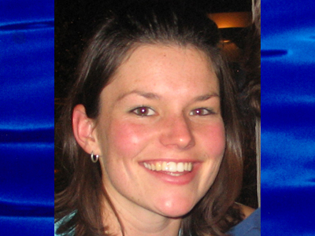
Angela was one of many highly qualified applicants from all over the world. The selection committee had a challenging job determining the most outstanding and appropriate recipient. Angela met all of the objectives of the program. She will be the first ILS Dr Ian Mackie Medical Fellowship recipient.
Dr. Ian Mackie would be very enthusiastic about this choice. Dr Ian Mackie was a world renowned water safety expert. He was the National Medical Advisor to Surf Life Saving Australia from 1976-1996 and was a member of the Australian Resuscitation Council for 14 years representing both Surf Life Saving Australia and the Royal Life Saving Society. Dr Mackie was the first chair of the ILS Medical Commission. He published lifesaving scholarly materials for over 4 decades. He received many awards for his contribution and for his welcoming and inclusive manner. Dr Ian Mackie died in 2002 and the ILS Dr. Ian Mackie Medical Fellowship is part of our effort to continue his great work.
Angela will be the ILS Dr. Ian Mackie Medical Fellowship recipient for 2006 and 2007. She will participate in the discussions of the ILS Medical Committee. She will attend one meeting per year that is relevant to her interests and project work. Angela will be mentored by the entire ILS Medical Committee throughout her ILS Fellowship. She will be encouraged to be an effective medical advisor to her national lifesaving organization and to the International lifesaving community.
By: Dr. Steve Beerman MD CCFP FCFP, Chair Medical Committee ILS
News from our members

Irish Water Safety celebrates 60 years

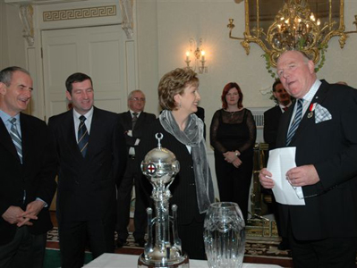

Irish Water Safety, the statutory body established to promote water safety in Ireland visited Áras an Uachtaráin on Friday 11th November to celebrate 60 years of promoting water safety in Ireland with the President of Ireland, Mary McAleese.
Fifty voluntary members from all over the country paid a visit to the President of Ireland at the occasion of the Associations 60th year. A number of the volunteers have given over 50 years of voluntary service to the state teaching swimming, lifesaving and rescue skills. They carried with them the much-coveted “Presidents Trophy” which was presented to the members by the late President of Ireland, Sean T O Ceallaigh in 1950. Young lifesavers compete for this trophy each year at the National Championships. This year the Clare Ladies team won it which demonstrates the equality of this sport that saves lives.
In this fast changing society where many social and community values appear to be disappearing, IWS is pleased that its voluntary activities and membership are increasing steadily. IWS works with many agencies and communities to reduce drowning and aquatic injuries and are pleased to note that drownings are slowly decreasing since the body was re- established as an independent statutory body in 2000. In 2004, 149 people drowned in Ireland, which is down on the previous ten year average of 180 people per year. IWS strives to reduce this figure further.
An area of great concern to IWS is the alarming rate of drownings through suicide and they are working hard at present to reduce this by working closely with the Samaritans. IWS is working closely with them and they’re “You Don’t have to be alone” sticker campaign where these stickers are strategically placed at known sites where people have taken their own lives. In addition they have commenced a collaborative Research project on Suicide Drowning with the Department of Psychiatry & Mental Health Research, UCD.
IWS proposes to conduct an epidemiologic study of all causes of drowning in Ireland both in inland waterways and coastal waterways. The intention is to establish possible correlates of suicidal drowning in Ireland such as demographics, access to waterways and certain features specific to a particular “high risk” site. This project is sponsored by the ESB Electric Aid fund and contributions from Local Authorities.
They intend to evaluate the various interventions that have been put in place thus far, with the aim of transferring successful strategies to other areas of the country and perhaps other method specific reduction strategies. Psychiatric Units around the country will be mapped with regard to their proximity to water volume. They also propose to explore the possibility that media reporting may contribute to an increase in site-specific risk areas for drowning. Finally differences and discrepancies between New Zealand and Ireland will be made to ascertain why there is such a discrepancy between the two countries given a relatively similar Geography and population. In 2003, six people drowned as a result of suicide in New Zealand, in Ireland 91.
61 trained lifeguards in Venezuela

YMCA Venezuela became an Associate Member of ILS in 2004.

This year YMCA Venezuela have trained 61 new lifeguards in the first National Training session for Lifeguards in Vargas State, which ended with a great success. The 61 candidates worked hard for a period of almost two weeks in the facilities of Oricao Club.

The Mayor of the city and the aquatics authorities handed over the Certificates to the Vargas Lifeguards. This is the first group in a National Program receiving their accreditations.
One of the most important activities during the training was an open forum about the law and regulations of aquatics safety in Venezuela. This document will be sent to the National Parliament for a study so that in the year 2006 the country can obtain the legislation. This is a huge challenge for YMCA Venezuela in order to have safer beaches next year.

For 2006 the National Tourism Institute will support YMCA for setting up 12 training courses in the most important tourist areas in Venezuela.

Source: José Mauricio Castro Forsyth
Email: jmauricioforsyth@gmail.com

Third term of office for DLRG President

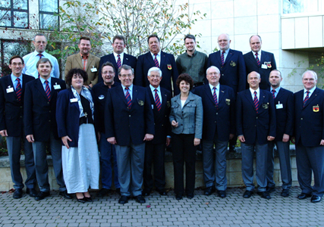

Dr. Klaus Wilkens was elected President of the DLRG (German Lifesaving Federation) for a third term with an overwhelming majority at the association’s General Assembly held in Weimar. The delegates of the world’s largest lifesaving organisation cast their votes based on continuity.
Only two things changed in the Board compared to the past term of office: The outgoing Parliamentary State Secretary in the Federal Ministry of the Interior, Ute Vogt, has become new Vice President of the DLRG, and Hans-Hermann Höltje takes over the office of Deputy Director of Rescue Service from Rainer Engelbracht.
“The Presiding Board did very good work in the past years and has already formulated clear objectives and tasks for the next four years. Our priorities are maintaining the level of swimming pool density in Germany, improving the swimming capabilities predominantly of young people and increasing safety at beaches and bathing and water sports locations,” said the old and new President of the DLRG when asked about the tasks ahead.
The “disastrous trend” in Germany to close more and more swimming pools is viewed with great concern by the DLRG. The Federal Conference adopted a resolution aimed at keeping public swimming pools open. The resolution says: Politics must be held co-responsible when there is evidence of deterioration in swimming capabilities already today, when the training courses of the organisations providing swimming instruction are drastically declining and when swimming lessons no longer take place at many schools.
The General Assembly calls upon municipalities and private operators of beaches and bathing and water sports locations to do justice to their duty to maintain safety and to take the necessary measures for the safety of users. The prerequisite for maintaining water safety will be a resolute risk assessment of the respective location, according to the DLRG. The actual need for safety measures will result from such analysis. The DLRG is able to perform the risk assessments with the help of trained experts. This effort by the humanitarian association is aimed at increasing water safety, predominantly at the inland waters, which have the highest drowning rates in Germany.
Report received by: Martin Janssen

Lifesaving law approved in Panama

On Thursday 24 November the National Assembly of Deputies of the Republic of Panama approved the Project of Bill n° 101, which regulates the profession of lifesaving and dictates other dispositions.
This new law aims to provide a general frame to lifesaving in Panama. Lifesaving has been developed in Panama since the 1940's when Adam Gordón and Pedro Almillátegui took the first steps to organise the rescue of human lives in aquatic environments. The new Law is now only waiting for the signature of the President of the Republic of Panama in order to become effective for the profession of lifesaving.

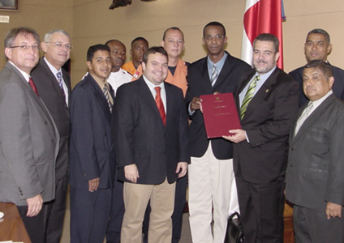
The original document was a proposal of the Lifeguards Association of Panama who were able to introduce this thanks to the Legislator Noriel Salerno in December 2003. Afterwards, the Deputies Vladimir Herrera, Luis Carlos Cleghorn and Agustín Escude presented the document to the plenary session of the Assembly in April of this year.
Panama is the first country of the region in having a general Law that formalizes this activity. The Lifeguards Association of Panama is the organization who from 1999 onward has oriented the efforts for the promotion of lifesaving. Now it has obtained the legal recognition of its activities through this new law.
ILS recognises this as a large step for lifesaving in Panama and the world and congratulates the Lifeguards Association of Panama for their efforts.
Source: Nelson Antonio Lara, Presidente Ejecutivo Asociación de Guardavidas de Panamá

Lessons in Emotional First Aid

The bronzed bravado of the Australian lifesaver is disguising the severe trauma that goes with witnessing people fighting for - and sometimes losing - their lives. Rescuers as young as 14 have witnessed drowning, suicide and severed limbs from surfboards - scenes that are as disturbing as a road accident.

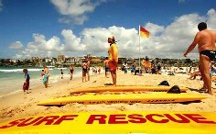

To help with the trauma lifesavers face, an internationally recognised peer support program dubbed "emotional first aid" is being implemented at Sydney's beaches. Surf lifesavers from Wanda, Narooma, Bondi, Clovelly and Cronulla were trained in the TIPS (traumatic incident peer support training) program and there are hopes that it will be adopted statewide.

One of the main problems is that while lifesavers are often in fear of losing their own lives during a rescue - and may be as traumatised as the victim - asking for help is contrary to the popular image of the volunteers. Fin chops, needlestick injuries, shark attacks, spearfishing accidents and anaphylactic shock from jellyfish stings are other hazards.

Patricia Newton began the TIPS program on the northern beaches 10 years ago, but lack of funding stalled its implementation elsewhere. The program recently received a community service award from the International Critical Incident Stress Foundation, which trains Red Cross and World Vision volunteers. It aims to provide immediate counselling to those who are, for example, suffering post-traumatic stress after a dangerous rescue or unsuccessful resuscitation, Ms Newton said.

By: Natasha Wallace, Sydney Morning Herald

HRH Prince Michael of Kent Certificate of Merit

Roy Phillips of West Midlands Fire Service, a previously trained UK lifeguard, was awarded the HRH Prince Michael of Kent Certificate of Merit for his outstanding courage and bravery during the tsunami in Asia on 26 December 2004.
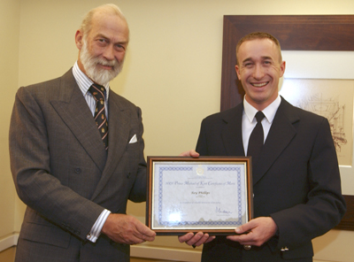
Roy was on a diving holiday in the resort of Patong Beach, Phuket (Thailand) and witnessed the devastating tsunami wave hitting the shore before he was totally submerged in water and pushed through a plate glass shop window by the wave. He managed to escape from the wreckage of the shop and rescued a young Thai woman who was trapped under a shop canopy. Roy then swam to the rescue of a man who was clinging onto a concrete stanchion, which was supporting unstable high voltage electricity cables and a transformer, and towed him to the precarious safety of a nearby roof. He then climbed to the safety of the roof, and went to rescue another man who was wading through the water in the street below, Roy had to act quickly as a further large wave was approaching. Roy ran down the roof, cutting his leg as he fell through a roof tile into the ceiling of the shop beneath. Roy reached the man just in time and pulled him to the safety of the roof, as the second wave hit.
Following these 3 amazing rescues, Roy crossed an unstable wall on 3 occasions to assist distraught persons who had become separated by the waves. This is a brief summary of the courageous actions of Roy Phillips over 30 minutes that resulted in him being awarded, this special Society award, given only at the discretion of HRH Prince Michael of Kent.

Record Number of Surf Lifesavers to Reduce Coastal Drowning this summer

A record number of trained surf lifesavers will be patrolling beaches this summer, in a concerted effort to keep our beaches safe and reduce coastal drowning and injury, according to new figures from the country’s major water safety and rescue authority, Surf Life Saving Australia (SLSA).

SLSA CEO, Greg Nance, said that 57 people drowned around the Australian coastline during 2004-05, a 42.5 per cent increase on the previous season, but below the five-year average of 58.
“Our surf lifesavers and lifeguards were involved in significantly more rescues and preventative actions last season (14,601 and 544,789 respectively), suggesting that the prevailing conditions were rougher, which is one explanation for the increase in the coastal drowning rate,” he said.

“With the support of government and partners such as DHL and Telstra, surf lifesaving services are constantly being expanded around the country to meet the organisation’s goal of zero preventable drowning deaths. “This season we will have more than 34,000 surf lifesavers on patrol around the country, the highest number in nearly 100 years, however if beachgoers continue to ignore basic safety messages by not swimming between the flags, people will still drown on our beaches,” he said.

The National Surf Safety Report, released to coincide with the first day of summer, found:
- Over 80 per cent of coastal drowning deaths were male.
- Just under half (44%) of all drowning victims were people aged from 20 to 39 years.
- The majority (65%) of people who drowned on the coast resided within 10km of the coastline
- Six international tourists drowned during 2004-2005.
- One-third of coastal drowning deaths occurred in the month of January, while the daily rate of drowning was more than twice as high on a weekend when compared to a weekday.
- Drowning deaths in NSW, QLD, WA and the NT were below that state’s or territory annual drowning average for the previous five years (2000-05). VIC, SA and TAS sustained a rate of drowning deaths above their respective five-year average.
- Not surprisingly, the most common activity at the time of drowning was swimming or wading (53 percent of drowning deaths).
- For deaths where the exact drowning location was recorded, just over half occurred within 1km of patrolled locations.
- Coastal drowning was more frequent in fair and relatively benign weather and sea conditions.
- Twenty-one non-fatal drownings were recorded over the 12 month period.
- A further 39 water related deaths in saltwater locations were identified for the year. These cases included intentional self–harm plus drownings locations outside the general vicinity of SLSA patrol services such as estuaries, rivers, creeks, lakes, and the open ocean.

The National Surf Safety Report was compiled using SLSA’s own incident data, cross-referenced with the National Coroners Information System (NCIS).

SLSA visits Ireland

Surf Life Saving Australia‘s President and Chief Executive Officer where on a courtesy Visit to Irish Water Safety this month. The drowning prevention strategies of Ireland and Australia were discussed over a four-day period when Irish Water Safety, the statutory body established to promote water safety in Ireland, played host to Surf Life Saving Australia.
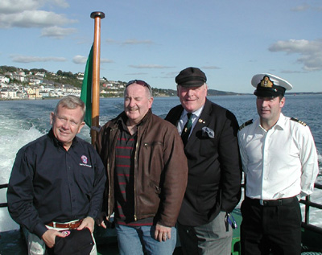
In welcoming the visitors the host and Chairman of Irish Water Safety, Mr Frank Nolan, expressed his belief that the primary goal of reducing all types of drowning accidents in Ireland is achievable with the ongoing commitment of the volunteers and the fine cooperation of the Irish Coast Guard and the other rescue services such as the Royal National Lifeboat Institution. However, from Irish Water Safety’s point of view the interchange of ideas and methodology of saving life through International partnerships is of paramount importance and this is done through ILS with the affiliated lifesaving organisations worldwide.
“We are particularly pleased to host Mr Ron Rankin (President) and Mr Greg Nance (Secretary General) of Surf Life Saving Australia before their busy summer season,” commented Mr Nolan. “Irish Water Safety shared information on how they conduct Lifeguard patrols; carry out risk assessments to make waterways safer as well as the many education and promotional programs presently being conducted to help reduce drownings in Ireland. Irish Water Safety Lifesavers are responsible for hundreds of rescues, first aid treatments, and awareness and educational programs every year, resulting in not only a significant economic value to communities nationwide, but also the priceless value of saving a life.”
During their trip to Ireland, the President and Secretary General of SLSA visited the Irish Coast Guard (ICG) in Tramore, many RNLI Lifeboat Stations, the ICG Rescue Helicopter at Waterford Airport, including several Irish Water Safety Venues.
“Surf Life Saving Australia has been a pioneer in rescue and resuscitation throughout the world and has a strong research and development focus. The Lifesavers of Australia are world renowned; in fact they are considered a national institution within Australia. The association between Irish Water Safety and Surf Life Saving Australia is a very historical one and this is reflected in a close working relationship on lifesaving matters over the years.”
“Despite the significant advancements in technology, techniques and knowledge, people still drown on Ireland’s waterways in unacceptable numbers – 149 tragic drownings in 2004 alone. Irish Water Safety in cooperation with Surf Life Saving Australia continues to develop practices in education, prevention and rescue, remaining the benchmark for aquatic rescue in Ireland and around the globe with fellow members of International Lifesaving Federation.”

Picture: The President of Surf Life Saving Australia Ron Ranking, the Chief Executive Officer SLSA Greg Nance, the Chairman of Irish Water Safety Frank Nolan and the Chief Executive Officer of IWS, John Leech aboard an Irish Naval Ship in Cork Harbour.

Meet the Royal Dutch Water Life Saving Association

The Royal Dutch Water Life Saving Association (KNBRD Reddingsbrigades Nederland) was founded in 1917 and became a member of FIS in 1952.
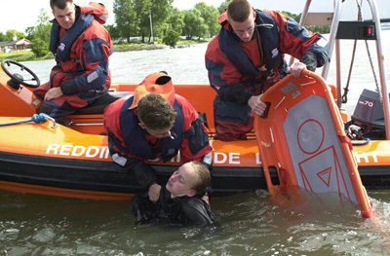

The KNBRD is the overall organisation of 182 life brigades throughout the Netherlands. Those life brigades have 30.000 voluntary members, youth included, of which about 5.000 are active as lifeguards during the summer season. The concentration of the life brigades is along the coast from North to South and further on along the shores of the inland lakes where water recreation takes place.
Their primary task is prevention; watching bathers and swimmers along the coastline. Their secondary task is to take action as accidents occur with small sailing boats and surfboards. To do their job, the lifeguards have to their disposal small lifeboats with radio communication on board. These can be various boats, e.g. all polyester or rigid inflatable with outboard motors. The KNBRD itself provides different models from all polyester patrol, to fast rescue boats. Further tasks of the lifeguards are of course first aid, resuscitation in cases of near drowning, taking care of lost children and so on.
For all the aspects of life saving, the KNBRD has an extensive education program, beginning with swimming lessons for 5 year olds to instructor courses for navigation of the life boats. All these courses are given by voluntary members of the KNBRD. In most cases the life brigades are financially supported by the local government in exchange for the security on the beaches of the municipal area.
For years they have asked their life brigades to take notes of their rescue operations. Only a few respond. The reason is that the lifeguards see their actions as their normal human duty and think that administration is superfluous. However they will keep working on this very important item, because with these data they can prove their right and necessity to exist. The KNBRD and its life brigades work together with all other life saving organisations in the Netherlands and is therefore represented in various consultation structures. The cooperation also takes place during SAR actions, mostly along the North Sea Coast, according to certain agreements. The coordination centre for these actions is the Kustwacht (Coast Guard), who decides which life saving organisation(s) must be alerted.
Besides the above mentioned tasks of the life brigades, they can be summoned by the national or local government to give aid in case of water catastrophes. There are arrangements with life brigades that they can provide a so called "disaster crew" with all the necessary life saving material. For this reason they yearly organise a big SOS exercise to control the alert system and to test the knowledge and capabilities of our lifeguards. They consider it their duty to provide their life brigades with good and up to date material and training courses.
The public depends more and more on the KNBRD life brigades while it's becoming more difficult to keep the voluntary members after they have learned the basics and last but not least, to find a sponsor for material and clothing. However, their mission stays: To prevent drowning and water related incidents for all people!
Contact details:
Dokweg 149, IJmuiden, Netherlands
Tel: (31.255) 54.58.58
Fax: (31.255) 51.25.84
Website: www.redned.nl

Lifesaving Sport

Australian Lifesaving team for Rescue 2006 announced

Australia’s defence of its world title took another step forward, with the announcement of the Australian Lifesaving Team to compete in the World Lifesaving Championships in Geelong and Lorne in February.

The team contains a number of reigning champions, including World Ironman and Ironwoman titleholders, Zane Holmes and Kristy Munroe, as well as Nathan and Kristyl Smith, the brother and sister duo who took out the Open Ironman and Ironwoman events at the 2005 Australian Surf Life Saving Championships.

Team captain, Zane Holmes, said it was a very well-balanced team with a good mixture of youth and experience, with strengths in the pool, on the sand and in the surf. “The fact that we are competing in Australia for the first time since 2000 in Manly will give us a definite advantage, and it will encourage all members to put in their best effort on their home turf,” he said.

The Australian Lifesaving Team for Rescue 2006 is:
Zane Holmes (c) - Kawana Waters QLD
Alex Bannon – Alexandra Headland QLD
Zane Campbell - Wanda NSW
Ryan Hartup - Cronulla NSW
Abby Lewtas - Anglesea VIC
David Lush - Maroochydore QLD
Kristy Munroe – Alexandra Headland QLD
Jason O’Pray - Maroochydore QLD
Jennifer Parry - Maroochydore QLD
Kristyl Smith - Northcliffe QLD
Nathan Smith - Cronulla NSW
Sarah Windsor - Mudjimba QLD

Rescue India 2005

The 2nd Lifesaving and 4th Endurance Swim Championships were held in Pune, India. The event counted 140 participants. John Baxter and Downie Langthorne from Surf Life Saving Australia were sent to assist and coach the athletes during the event.
The Endurance Swim Championship and the Lifesaving Championship (pool events) were conducted over two days at the Swimming & Life Training Centre, Balgandharva Swimming Pool. The Lake Swim (15 km) and the Open Water Lifesaving Evnts were held at the Bhugaon Lake. Both the events were a great success as many previous records were broken.
The 140 participants came from 8 districts. Many athletes form other districts could not make it due to financial constraints. RLSS (I) hopes to be able to finance the participation of such districts in the future. The teams form the Navy from Mumbai, the Army (Bombay Sappers) and Central Reserve Police Force also participated in the event. These athletes had done the lifesavers’ course with RLSS (I) to enable them to take part in lifesaving championships as this is a mandatory require-ment.
Training camp
A training camp was held for athletes as a run up to the Championships. It was of great value to most particularly for those who came from other districts. Due to the unavailability of equipment they were unable to train for this event. The Australian instructors were of immense help by teaching the correct techniques and by giving them important tips that only a champion would know. Their contribution in the conduct of the pool events was important and well received by the officials conducting the show under the able leadership of Mrs Sandhya Kotbagi, President Pune District Branch RLSS (I) and Mr Jitendra Khasnis, Director Sports, RLSS (I). The Australian Coaches’ presence and their monitoring the same gave them confidence in running the event as it would be in any country where ‘Lifesaving Sports’ activity has been practiced for decades. RLSS (India) is only seven years old and any word of encouragement and praise to its volunteer force for its dedicated effort prompts it to do better.
All India Lifesavers’ Conference.

For the first time an all India Conference in Lifesaving was held over 4 hours. RLSS (I) Zone and District Presidents accompanied by their council members and members of the National Working Council were present. The objectives of the conference were to discuss:
- Districts’ performance and feedback to National HQ.
- Standardisation of RLSS (I) Working & Reporting.
Methods and means to expand RLSS (I) reach and spur its growth.
- Greater attention to schools and younger groups.
- Promulgation of action plan by Districts.
- Quantification of awareness promotion volume and marrying it with training effort and schedule.
- Liaison with Corporate, the State/Central Govt. for Recognition & Support.
- Sharing views and experiences while promoting lifesaving.
- Technical subjects related to First Aid Lifesaving and Life-Guarding.
- Notice for “Elections” in 2007.
The aim was to get all districts on the same grid. A number of issues were thrown up during discussions such as:
- Availability of lifesaving equipment to train and save lives in actual conditions. Availability of books and training material for training in lifesaving and first aid.
- The need to rotate venues for lifesaving events and championships.
- The need to get Indian officials and coaches match up to international standards by understudying established officials at international events.
- Frequency of lifesaving championship and their venue.
- Bids for Rescue INDIA 2006 and 2007. Criteria and modalities for making a bid.

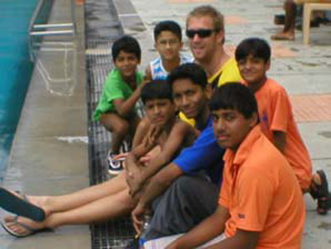

Picture shows Downie Langthorne (SLSA) with young lifesaving athletes
Report sent by Mrs Kavita Sharma, Secretary General, RLSS (I)

Newsletter compiled by
Dr. Harald Vervaecke - Secretary General
Sandra Harthoorn - Executive Assistant

